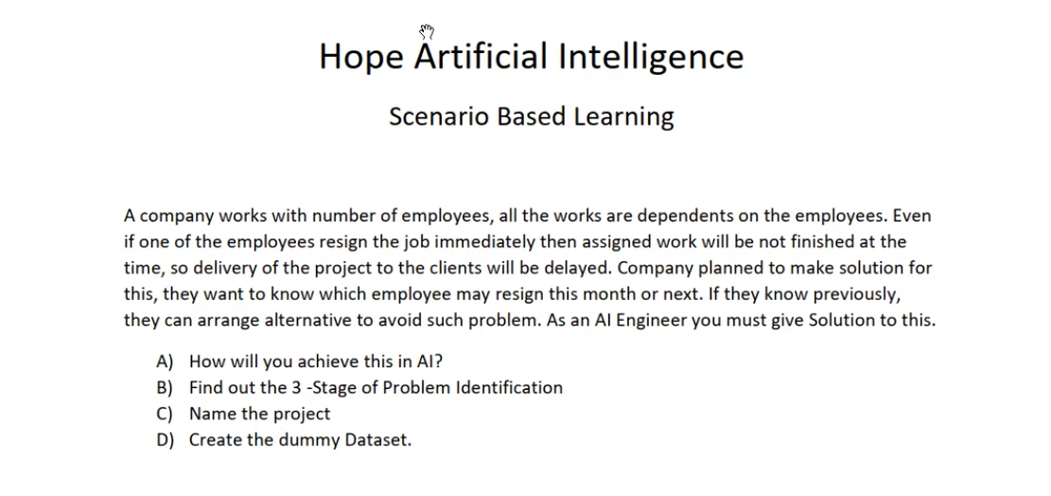
Problem Statement Analysis:
Prediction Goal: Which employee may resign this month or next month
Purpose of Prediction: Avoid delays in project completion
S1: Domain Selection: Date Time series Analysis
S2: Supervised Learning Classification
Sample Data Set:
Employee | Project | Possible Resign Date | Final Outcome
E1 | HR | 06-30-2025 | This month
E2 | Finance | 07-30-2025 | Next month
E3 | Marketing | 07-30-2025 | Next month
E4 | SAP | 06-30-2025 | This month
E5 | HANA | 10-30-2025 | Future
E6 | Remittance | 11-30-2025 | Future
E7 | Payroll | 12-30-2025 | Future

